OPTIMUM FACTOR COMBINATION AND PRODUCT-MIX
A profit maximizing entrepreneur will seek to minimize his cost for producing a given output, or to put it in another way, he will maximize his output for a given level of outlay. The choice of a particular combination of factors by an entrepreneur depends upon

(a) technical possibilities of production, and
(b) the prices of factors used for the production of a particular product.

Technical possibilities of production are represented by the isoquant map.

ISO-COST LINE

An iso-cost line shows various combination of two factors that the firm can buy with a given outlay. How the iso-cost line is drawn is shown in Fig below where on the X-axis we measure units of labour and on the Y-axis we measure units of capital. We assume that prices of factors are given and constant for the firm. In other words, we are considering a firm which is working under perfect competition in the factor markets. Further suppose that the firm has Rs. 300 to spend on the factors labour and capital and price of labour is Rs. 4 per labour hour and the price of capital is Rs. 5 machine hour. With outlay of Rs. 300, he can buy 75 units of labour or 60 units of machine hours (i.e. capital). In other words, if the firm spends its entire outlay of Rs. 300 on factor X, it buys 75 units or OB of labour hours and if it spends its entire outlay of Rs. 300 on capital it buys 60 units or OA of machine hours The straight line AB which joins points A and B will pass through all combinations of labor and capital which the firm can buy with outlay of Rs. 300, if it spends the entire sum on them at the given prices.

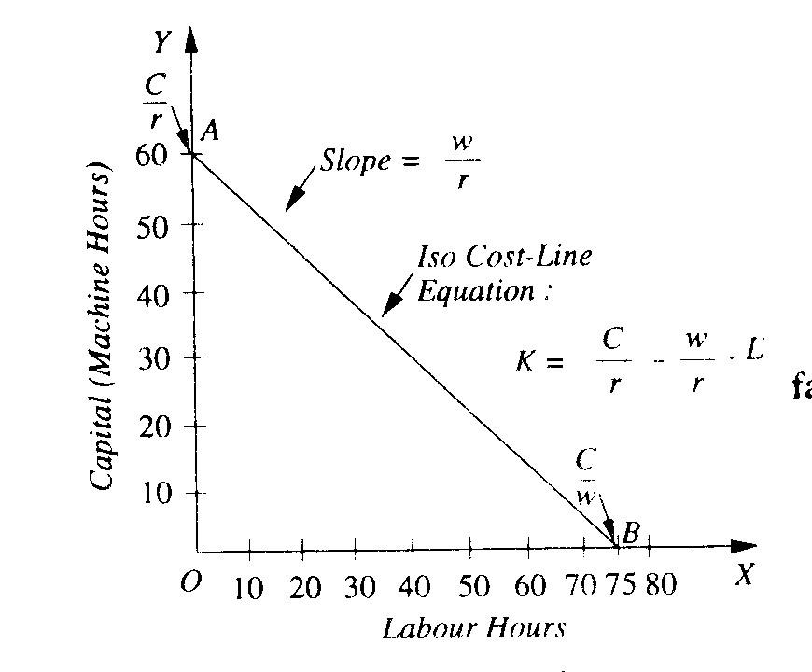

An iso-cost line is defined as the locus of various combinations of factors which a firm can buy with a constant outlay. The iso-cos t line is also called the price line or outlay line.

The Equation of the Iso-Cost Line.

The total cost incurred on the factors of production for production of a commodity is equal to the sum of the payments made for labour and capital. Now, payment for the labour used is equal to the wage rate (w) multiplied by the amount of labour used Thus w.L represents the total payment made for labour. Similarly, r.K is the total payment made for capital where r is the price per unit of capital and K is the quantity of capital used. The total cost equation can therefore be described as follows.

C =w.L + r.K
Where C is the total cost incurred by the firm on purchasing the quantities of factors used for production. Given the prices of factors, the iso-cost equation can be rearranged as under to express in the intercept-slope form:
C = wL + rK

K = C ─ w.L

K = 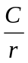 ─ 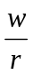.L
Where represents the intercept of the iso-cost line on the Y-axis and represents the factor price ratio and is equal to the slope of the iso-cost line.

Slope of the Iso-Cost Line:
The slope of the iso-cost line can be proved to be equal to the ratio of price of labour (w) and price of capital (r).As explained above, the vertical intercept OA that represents the quantity of factor capital if C entire cost outlay is spent on it is equal to . Similarly, the horizontal intercept OB representing the quantity of labour purchased if entire cost is incurred on purchasing it is equal to 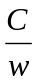.

Now, the slope of the iso-cost line is :

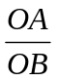 = ÷

= . 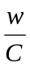
=
Thus the slope of the iso-cost line is equal to the ratio of factor-prices .

Shift in the Iso-Cost Line

Now, the iso-cost line will shift if the total outlay which the firm wants to spend on the factors changes. Suppose if the total outlay to be made by the firm increases to Rs. 400, prices of factors remaining the same, then it can buy 100 units of labour hours (i.e., OB' of labour ) or 80 units of machine hours (i.e., OA' of capital) if it spends the entire sum on either of them. Thus, the new iso-cost line will be A'B' which will be parallel to the original iso-cost line AB. If the outlay which the firm intends to make further increases to Rs. 500, then iso-cost line will shift to the position A"B". Thus any number of iso-cost lines can be drawn, all parallel to one another, and each representing the various combinations of two factors that can be purchased for a particular outlay. The higher the outlay, the higher the corresponding iso-cost line.

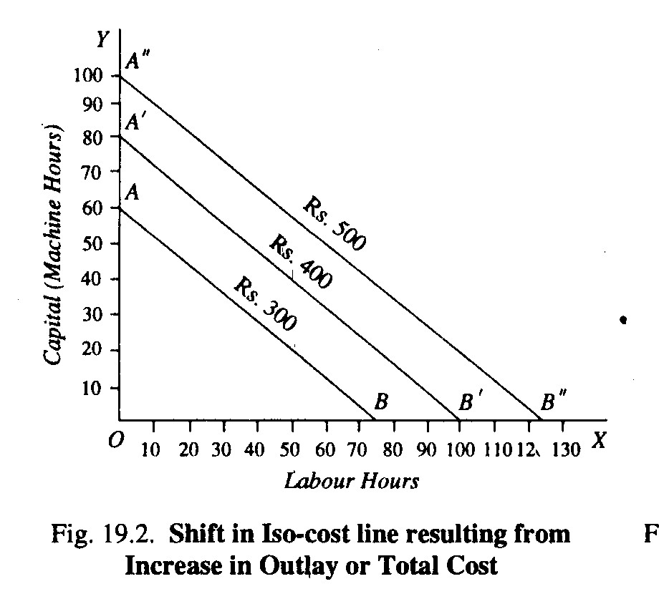

The iso-cost line will also change if the prices of factors change, outlay remaining the same. Suppose the firm's outlay is Rs. 300 and the prices of labour and capital are Rs. 4 and Rs. 5 respectively. Then the iso-cost line will be AB as shown in Fig. 19.3. If now the price of labour falls to Rs. 3, then with the outlay of Rs. 300 and Rs. 3 as the price of labour the firm can buy 100 units of labour if it spends the entire outlay on it. OC represents 100 units of labour. Therefore, as a result of the fall in price of labour from Rs. 4 to Rs.3, the price line changes from AB to AC. If the price of labour rises from Rs. 4 to Rs. 6 per hour the iso-cost line will shift to AD. Likewise, if the price of capital changes, the outlay and the price of labour remaining the same, the iso-cost line will shift.

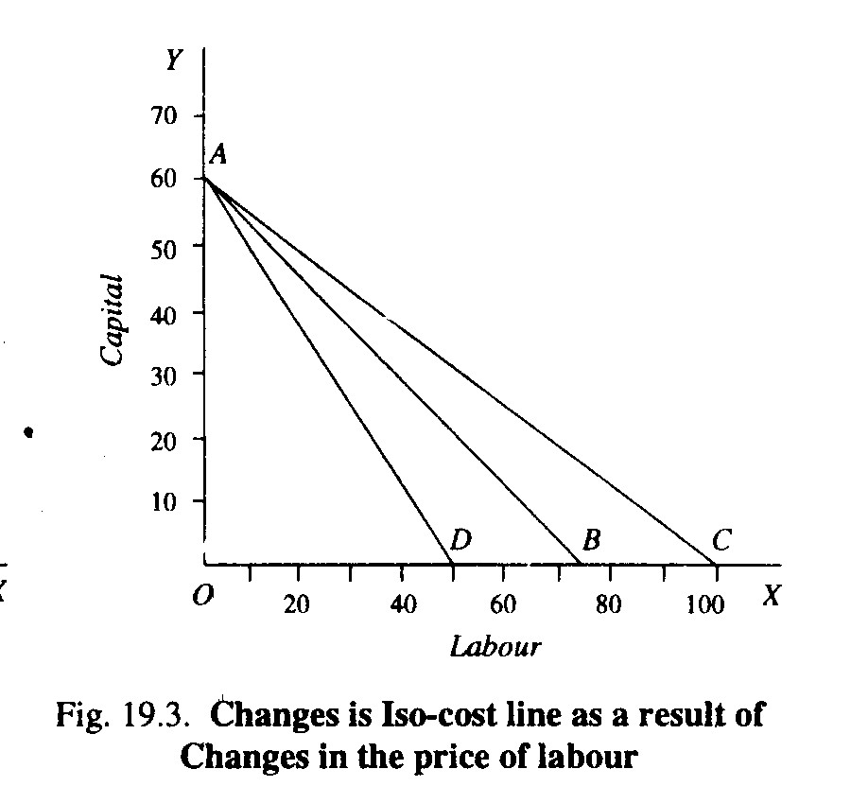

It is clear from above that the iso-cost line depends upon two things
- prices of the factors of production, and
- the total outlay which the firm has to make on the factors.

LEAST-COST COMBINATION OF FACTORS: CHOICE OF INPUTS

An equal product map or isoquant map represents the various factor combinations which can yield various levels of output. A family of iso-cost line represents the various levels of total cost or outlay, given the prices of two factors. The entrepreneur may desire to minimize his cost for producing a given level of output, or he may desire to maximize his output level for a given cost or outlay.

To produce a given level of output, the entrepreneur will choose the combination of factors which minimizes his cost of production, for only in this way he will be maximizing his profits. Thus a producer will try to produce a given level of output with least-cost combination of factors. This least-cost combination of factors will be optimum for him.
Suppose the entrepreneur has decided to produce 500 units of output which is represented by isoquant Q. The 500 units of output can be produced by any combination of labour and capital such as R, S, E, T and J lying on the isoquant. Now, glance at the figure will reveal that for producing the given level of output (500 units) the cost will be minimum at point E at which the iso-cost line CD is tangent to the given isoquant. At no other point such as R, S, T and J, lying on the isoquant Q the cost is minimum. It will be seen from Fig, 19.4 that all other points on isoquant Q, such as R, S, T, J lie on higher iso-cost lines than CD and which will therefore mean greater total cost or outlay for producing the given ,output. Therefore, the entrepreneur will not choose any of the combinations R, S, T and J. We thus see that factor combination E is the least-cost combination of labout and capital for producing a given output. Factor combination E is therefore an optimum combination for him under the given circumstances. Hence we conclude that the entrepreneur will choose factor combination E (that is, OM units of labour and ON units of capital) to produce 500 units of output.

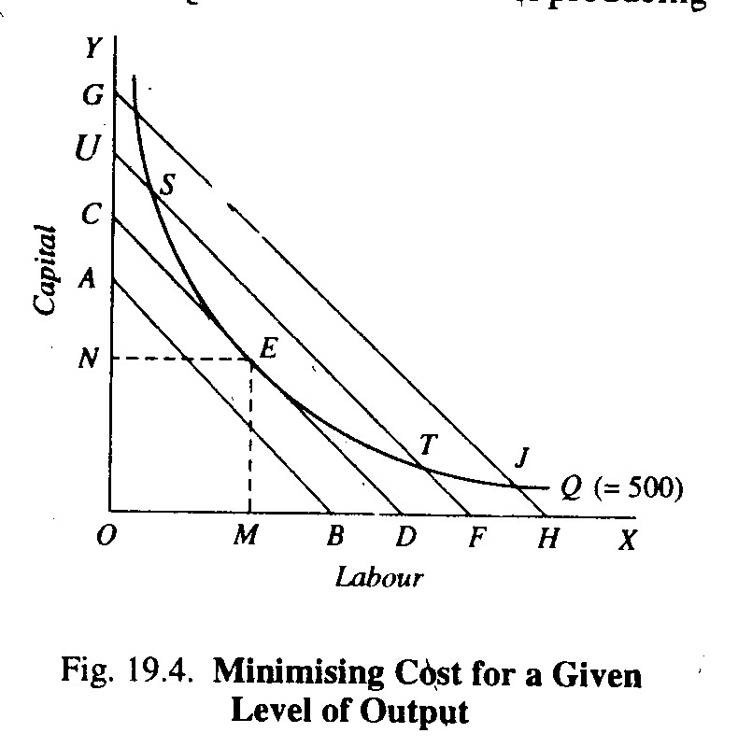

Output Maximization for a Given Level of Outlay (i.e. Cost)

Suppose the firm has decided upon an outlay which it has to incur for the production of a commodity. With a given level of outlay, there will be a single iso-cost line that represents the outlay that firm has decided to spend. The firm will have to choose a factor combination lying on the given iso-cost line. Consider Figure 19.5. Suppose the firm has decided to incur an outlay of Rs. 5000 on labour and capital which is represented by the iso-cost line AB. The firm has a choice to use any factor combination of labour and capital such as R, S, E, T, J etc. lying on the given iso-cost line AB to produce the product, An isoquant map showing a set of isoquants that represents various levels of output (200, 300, 400, 500 units) has been superimposed on the given iso-cost line AB. A glance at the Figure 19.5 reveals that the firm will choose the factor combination E consisting of ON of labour and OH of capital. This is because of all the factor combinations that lie on the given iso-cost line AB, only the factor combination E enables the firm to reach the highest possible isoquant Q₃ and thus produce 400 units of output. All other combinations of labour and capital that lie an the given iso-cost line AB such as R, S, T, J etc. lie on lower isoquants showing lower levels Given Outlay of output than 400 units.

